5394 Five Forks Trickum Road
Lilburn, Georgia 30047
Phone: 678-380-4656
Fax: 678-380-4652

Store Hours:
Monday – Friday 9:30AM – 8:00PM
Saturday 8:00AM – 5:00PM

Catering Coordinator:
Joel Guldenschuh
AlwaysFreshCatering@gmail.com

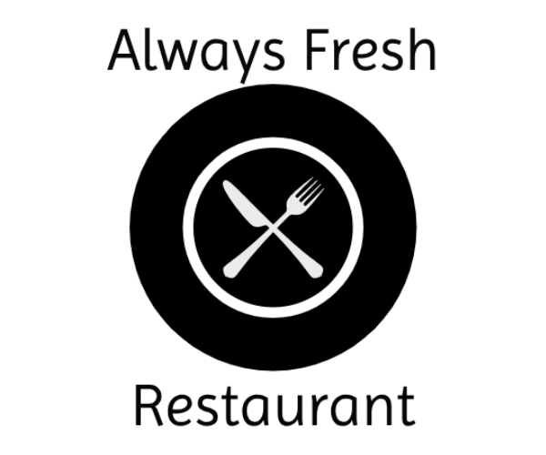

Boxed Lunch Catering
Thank you for considering Always Fresh for your catered affair. Boxed lunches are served with lettuce and tomato on the sandwiches and the appropriate condiments on the side as well a napkin and disposable utensils.

Please choose 1-2 sandwich options and 1-2 sides/soup options. Our sandwiches are served on your choice Sourdough, Wheatberry or Croissant.

Boxed Lunch: Please choose one option
Whole sandwich, chips and a piece of fruit $11.50
Whole sandwich and chips $10.00
Whole sandwich and a side $12.00
Whole sandwich, chips and a side $12.50
Half a sandwich and a side $10.00
Half a sandwich, chips and a side $10.50
Half a sandwich and a cup of soup $11.00
Large Garden Salad $9.50
Bowl of soup and a small garden salad $12.50
Whole Kids Sandwich, fruit cup and chips $10.50

Boxed Lunch Catering Menu

Soups/Salads:
Country Vegetable Soup
Loaded Baked Potato Soup
Broccoli Cheese Soup
Chicken and Rice Soup
Brunswick Stew
Chili

Sandwiches:
Pimento Cheese Sandwich
Chicken Salad Sandwich
Turkey Sandwich
Ham Sandwich
Combo Sandwich
BBQ Pork Sandwich

All deliveries are subject a 10% delivery charge (minimum charge of $50) and a 6% sales tax

Kids Sandwiches:
Grilled Cheese Sand
PB and J Sandwich
Banana Jamma Sandwich

Side Items:
Green Beans
Butterbeans
Collard Greens
Mashed Potatoes and Gravy
Broccoli Cheese Casserole
Cabbage Casserole
Pineapple Casserole

Side Items continued:
Sweet Potato Soufflé
Mac and Cheese
Potato Salad
Cole Slaw
Cucumber and Tomato Salad
Sliced Tomatoes
Fruit Cup

Desserts: add dessert for $1.25
Chocolate Chip Cookie
Peanut Butter Cookie
Brownie

